Tarea obligatoria UD 12.5

DELIMITER $$
drop procedure if exists error1 $$
create procedure error1(p_id int)
MODIFIES SQL DATA
BEGIN
DECLARE CONTINUE HANDLER FOR 1062
SELECT CONCAT("su codigo",p_id,"ya existe") AS "aviso de error grave";
insert into clientes (id_clientes) values (p_id);
end $$
DELIMITER ;
call error1(14)

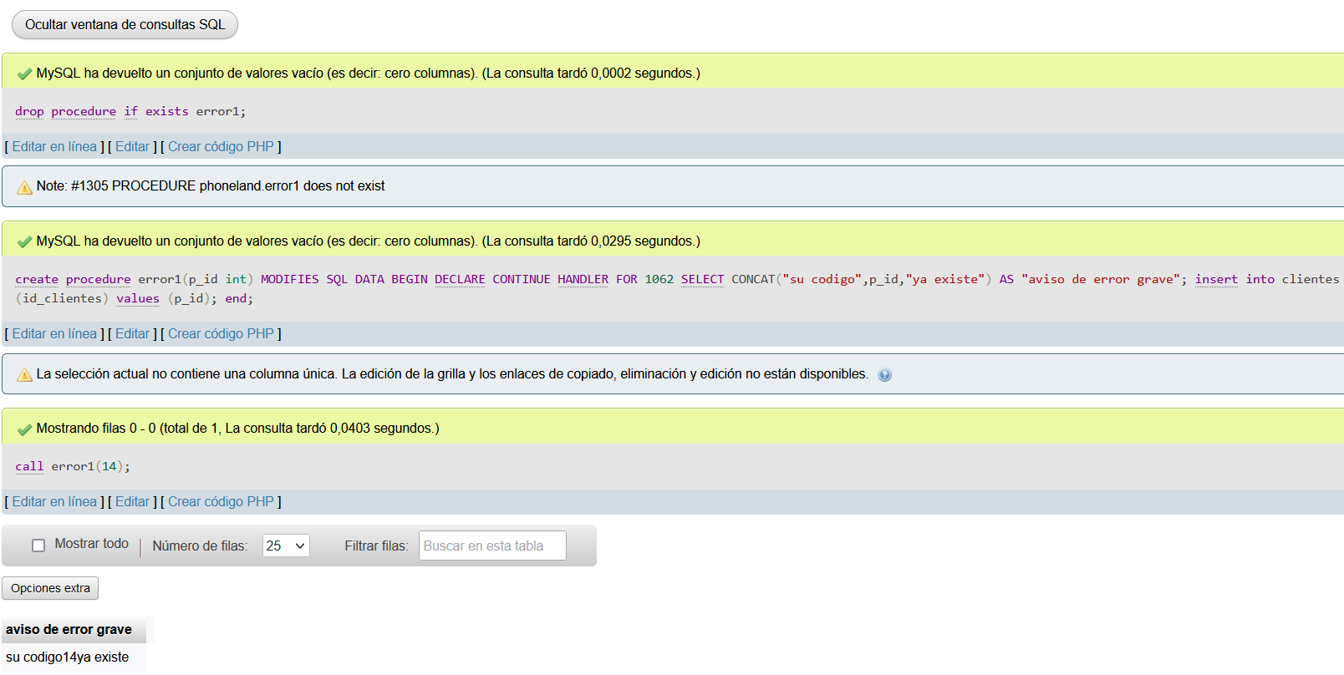
DELIMITER $$
drop procedure if exists error1 $$
create procedure error1(p_id int,p_alumno varchar(30))
MODIFIES SQL DATA
BEGIN
DECLARE CONTINUE HANDLER FOR 1062
SELECT CONCAT("su codigo",p_id,"ya existe") AS "aviso de error grave";
DECLARE CONTINUE handler for 1054
select concat("No existe el campo nombre") AS"aviso de error grave";
insert into alumno (id,alumno_name) values (p_id,p_alumno);
end $$
DELIMITER ;
call error1(1,"Maria")

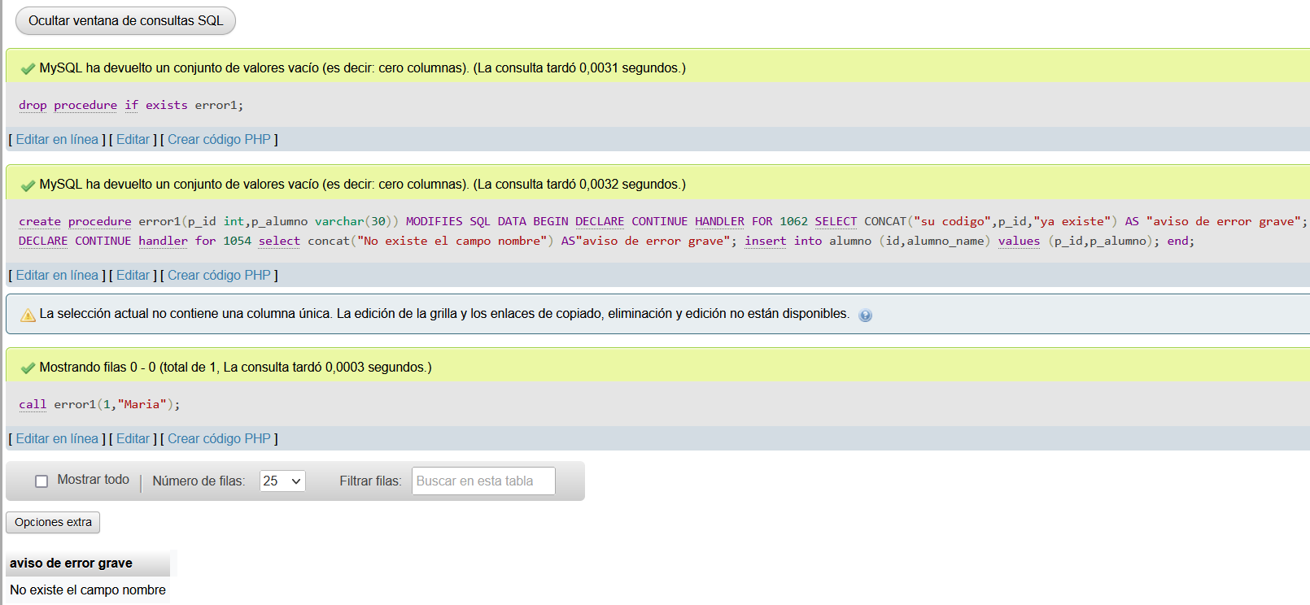
commit confirma los cambios

CREATE TABLE audita ( mensaje VARCHAR(200) );

DELIMITER $$

CREATE TRIGGER `TRIGGER2`
AFTER UPDATE ON `alumno`
FOR EACH ROW BEGIN
INSERT INTO audita
VALUES (
CONCAT('modificacion realizada por ', USER(),
' el dia ', NOW(), ' valores antiguos ', OLD.id, ' y ',
OLD.nombre, ' valores nuevos ', NEW.id, ' ', NEW.nombre)
);
END
$$
DELIMITER ;

update alumno
set nombre='Bilbo'
where id=11

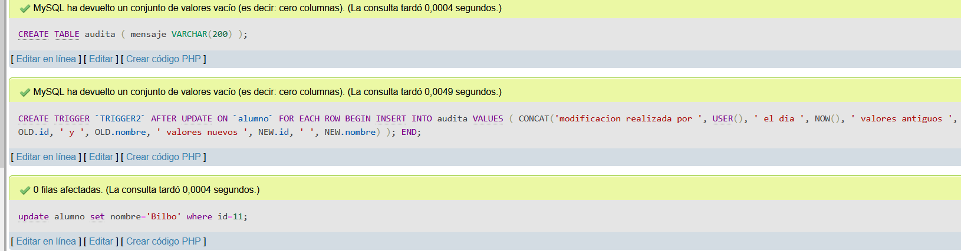
CREATE TABLE alumnos_replica
( id INT PRIMARY KEY ,
alumno VARCHAR(30) )

DELIMITER $$
CREATE TRIGGER `TRIGGER1`
BEFORE INSERT ON `alumno`
FOR EACH ROW BEGIN
INSERT INTO alumnos_replica VALUES (NEW.id,NEW.nombre);
END
$$
DELIMITER ;

DELIMITER $$
